|  |  |
| --- | --- |
| **Sprint 3** | **CREATING NODE RED SERVICES** |
| Team ID | PNT2022TMID17729 |
| Project Name | Project – Personal Assistance for Seniors Who Are Self-Reliant |

# NODE-RED DESIGN WITH FORM NODE:

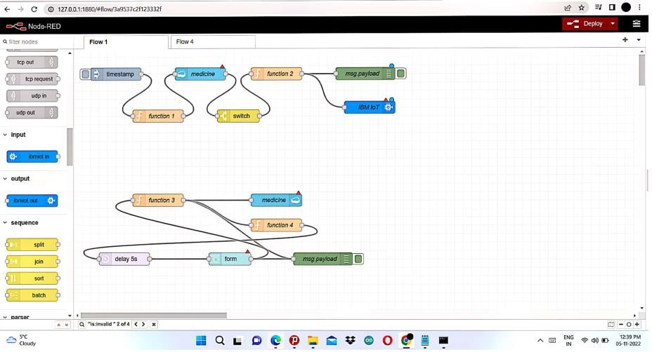

**STEPS TO ADD INPUT FORM TO UI:**

1. Configure the UI input form
2. Add a group with the name user
3. Add a tab with the name Home and press add
4. Press add
5. Give the UI from a name Insert a new User and add the input fields for medicine name, time and date
6. Add a function node and insert code and wire the nodes
7. Open in a new browser tab https://[your-host]/ui/
8. Insert required details and press submit
9. Now wire the function as input for the database as shown in about layout
10. Press Deploy.

**WEB UI INTERFACE FOR USERS:**

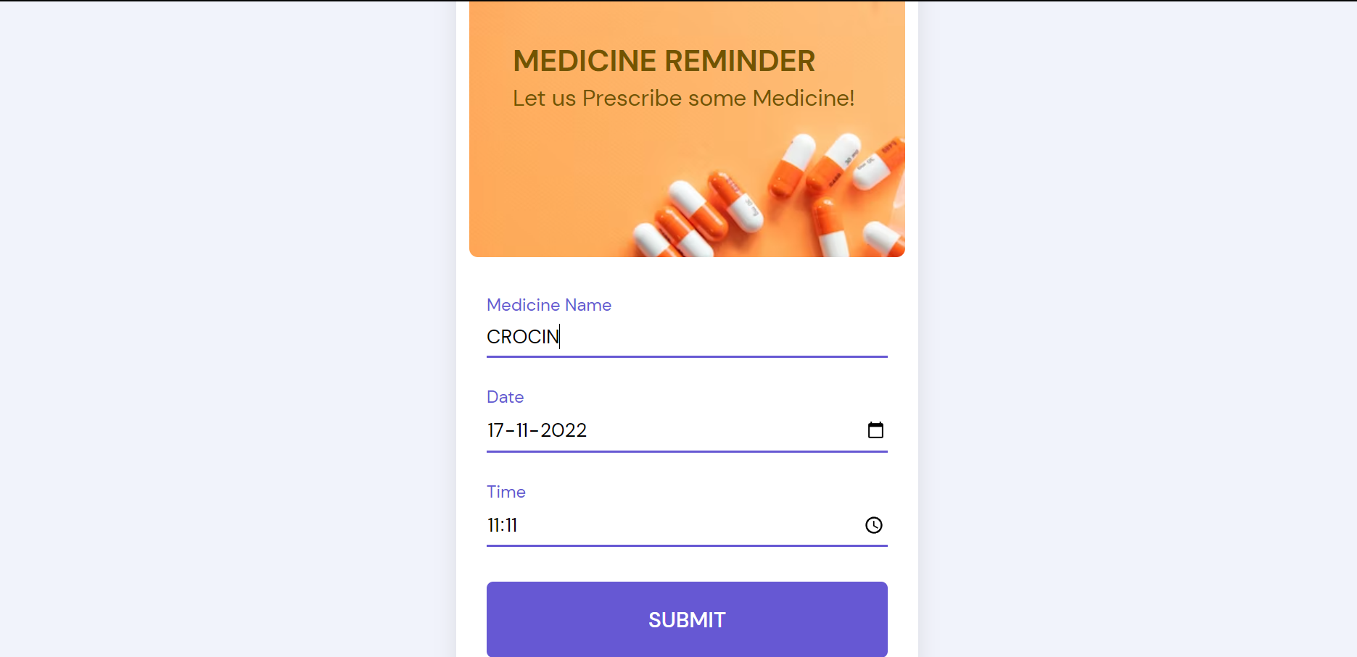

**WEB UI INTERFACE FOR USERS:**

In the below image, depicts the web UI interface or web application for DOCTORS to enter the medication details like name, date and time for patients.

# NOTE:

On clicking submit the details will be saved in the Cloudant database and will be accessed by function nodes used in the node red design.

Upon comparison with time specified in function node the apt medicine name in the text format is passed on to the Text-To-Speech service (Implementation is available in sprint

**CREATING IBM PLATFORM:**

